PROJECT NAME: NETFLIX

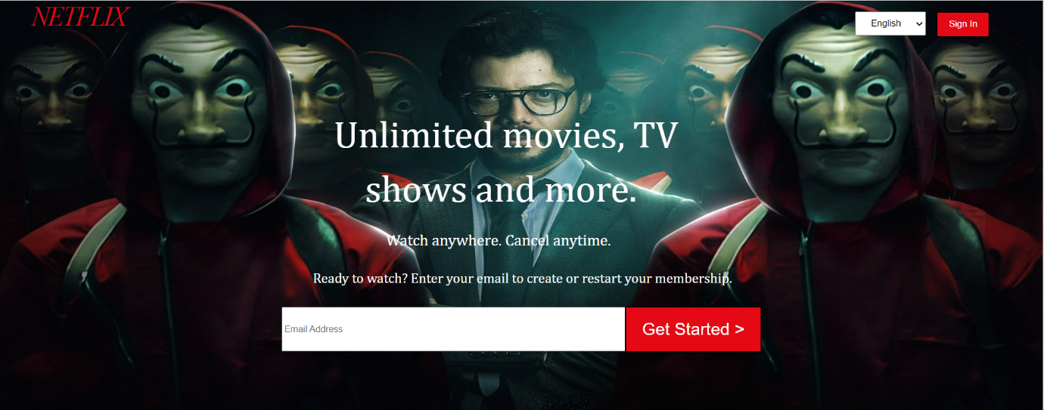

Overview:

Netflix is a subscription streaming service that offers a wide variety of award-winning TV shows, movies, anime, documentaries, web series and many more things. You can watch as much as you want.

In my project

1.Homepage

1.header section

Inside header section you can first sign in by filling all your details such as your Gmail.

2.enjoy tv section

Here you can watch all the tv content such as movies, documentaries, web series and much more.

3.download section

Here you can download any movies, web series, documentaries and enjoy on your devices.

4.watch everywhere section

Here you can watch downloaded content everywhere.

5.profile for children section

Here you can also make profile for your children in which you can see different entertaining content.

6.frequently asked question section

Here you also asked question over there. Such as what is Netflix.

7.footer section

Inside footer section my Gmail, Instagram, Facebook account link is there.

2.Listingpage

1.header section

Inside header section you can first sign in by filling all your details such as your Gmail. After that you can see all the related information of the movie, web series which you select.

2.trailer section

Here you can see trailer of that movie or web series.

3.more like this section

Here you can see similar content related to that movie, web series which you select.

4.footer section

Inside footer section my Gmail, Instagram, Facebook account link is there.

3.Detailpage

1.header section

Inside header section you can first sign in by filling all your details such as your Gmail. After that you can see all the related information of the movie, web series which you select. Here you also see imdb rating of that movie, web series.

2.season section

Here you can see all the seasons of that particular web series which you have select.

3.popular clip section

Here you can see all the popular clip of that movie, web series which you have select.

4.footer section

Inside footer section my Gmail, Instagram, Facebook account link is there.